Machine Learning in Practice
Unsupervised Learning and Feature Engineering for Mental Health Analysis in the Technology Sector
A Case Study on Employee Mental Health Survey Data
Migael Meyer
Matriculation Number: 9217171
Data Science
Machine Learning- Unsupervised Learning and Feature Engineering 11 September 2026

Table of Contents
Table of Contents ............................................................................................................................. i
List of Figures and Tables .............................................................................................................. ii
Figures & Tables…….................................................................................................................... ii
List of Abbreviations ......................................................................................................................ii
- Introduction .................................................................................................................................1
- Data Overview and Exploration .................................................................................................. 1
- Data Preprocessing ..................................................................................................................... 2
  - First Iteration: Direct Encoding ............................................................................................ 3
  - Refined Iteration: Feature Selection and Principled Imputation .......................................... 3
- Methodology ...............................................................................................................................5
  - Dimensionality Reduction: Principal Component Analysis ................................................. 5
  - Determining the Number of Clusters: The Elbow Method ................................................... 6
  - Clustering Approach: K-Means and Alternatives Considered............................................... 7
  - Final Clustering and Cluster Profiles .................................................................................... 8
- Results and Critical Interpretation .............................................................................................. 9
- Recommended Next Steps ........................................................................................................ 10
- Conclusion ................................................................................................................................ 10
Bibliography ................................................................................................................................. 11
Appendices .................................................................................................................................... 12 Appendix A: Code Repository ................................................... Error! Bookmark not defined.
Appendix B: Full Cluster Profile Table .................................................................................... 12
Appendix C: Supplementary Figures ........................................................................................ 12

List of Figures and Tables

Figures
Figure 1: Elbow Method for Optimal Number of Clusters (Initial Feature Set) — Section 4.2
Figure 2: PCA Visualisation of K-Means Clusters, k = 2 (Initial Feature Set) — Section 4.2

Tables
Table 1: Selected Features for the Refined Clustering Analysis — Section 3.2
Table 2: PCA Explained Variance, Refined Feature Set — Section 4.3
Table 3: Cluster Sizes, Refined Feature Set — Section 4.4
Table 4: Cluster Profile — Mean Feature Values by Cluster — Section 4.4

List of Abbreviations
Abbreviation | Meaning
PCA | Principal Component Analysis
HR | Human Resources
IT | Information Technology
OSMI | Open Sourcing Mental Illness (survey publisher)
DBSCAN | Density-Based Spatial Clustering of Applications with Noise
UMAP | Uniform Manifold Approximation and Projection

1. Introduction

An HR department planning a mental-health support programme needs to understand differences in employees’ experiences and support needs. This case study uses the OSMI Mental Health in Tech Survey 2016 to explore whether clustering respondents can reveal meaningful groups relevant to this objective (Open Sourcing Mental Illness [OSMI], 2016).
The report introduces the dataset, examines its preprocessing challenges, and compares successive feature sets and clustering approaches. It then evaluates the selected solution, interprets the cluster profiles, and concludes with limitations and recommendations for further analysis.

2. Data Overview and Exploration
The analysis uses the OSMI Mental Health in Tech Survey 2016, containing 1,433 respondents and 63 variables (OSMI, 2016). The dataset was loaded from a comma-delimited CSV file and includes binary responses, categorical variables, numerical age values, and free-text answers.
Exploration identified substantial missingness. The question about negative consequences of disclosure to clients or business contacts had 90.0% missing responses, while the tech/IT-role question had 81.6% missing responses. Cross-tabulation showed that employer classification was missing for all 287 self-employed respondents, and the tech-role question was answered only by the 263 respondents working for non-tech employers. These patterns suggest that some missing values reflect question applicability rather than nonresponse.
Recorded ages ranged from 3 to 323 years. Ages 3 and 323 were identified as implausible for this employment survey, while ages 15 and 17 were retained because no eligibility rule had been established to justify excluding them. These findings informed the subsequent treatment of missing values, age correction, and feature selection described in Section 3.

3. Data Preprocessing

Preprocessing was developed through three iterations: an initial approach using all available variables, a reduced six-feature model with median imputation, and a final four-feature model that addressed implausible ages and excluded questions with missingness linked to employment circumstances.

3.1 First Iteration: Direct Encoding

Binary “Yes” and “No” responses were mapped to 1 and 0. Remaining categorical and free-text columns were one-hot encoded using pandas.get_dummies(), increasing the feature count from 63 to 3,216 while retaining all 1,433 respondents. Following encoding, 2,603 missing entries remained and were replaced with zero. The resulting numerical matrix was standardised before clustering.
This approach introduced two limitations. Replacing missing binary values with zero treated unanswered or non-applicable responses as “No,” potentially distorting similarities between respondents. Encoding distinct free-text answers also expanded the feature space substantially, potentially giving rare responses undue influence on clustering. These limitations motivated a second iteration using fewer features and median imputation.

3.2 Refined Iteration: Six - Feature Selection and Median Imputation
Six features were selected to create a smaller, interpretable representation of employment circumstances, treatment-seeking and age. Their missingness before imputation is shown in Table 1.

Feature | Type | Missing responses | Missing (%)
Self-employed | Binary | 0 | 0.0
Employer primarily a tech company/organisation | Binary | 287 | 20.0
Primary role related to tech/IT | Binary | 1,170 | 81.6
Has previous employers | Binary | 0 | 0.0
Has sought professional treatment for a mental-health issue | Binary | 0 | 0.0
Age | Numerical | 0 | 0.0

Table 1: Features selected for the six-feature model and their missingness before imputation.
Missing values were replaced with each feature’s median using SimpleImputer(strategy="median"). Only employer classification and tech-role status contained missing values; both had an observed median of 1. Consequently, all missing entries in these columns were replaced with “Yes.” The six features were then standardised before clustering, retaining all 1,433 respondents.
Although this approach reduced the feature count from 3,216 to six, it obscured the apparent question-routing patterns identified during exploration. Self-employed respondents were assigned a positive employer-classification value, while every missing tech-role response became “Yes.” In particular, the tech-role feature depended heavily on imputation because 81.6% of its values were missing.
The recorded ages were initially retained to reproduce this model. The missingness patterns and implausible ages therefore motivated a further preprocessing iteration, described in Section 3.3.

3.3 Third Iteration: Age correction and Four – Feature Selection

A further iteration addressed implausible ages and the two features whose missingness followed employment circumstances. Ages 3 and 323 were marked as missing and replaced with the median of the remaining observed ages. Ages 15 and 17 were retained because no confirmed eligibility rule justified excluding them. This preserved all 1,433 respondents.
The effect of age correction was first examined using the six-feature model. At k = 9, the silhouette score decreased from 0.6206 to 0.5388, demonstrating sensitivity to the two implausible ages. The original k = 9 solution had also placed the respondent aged 323 in a cluster alone.
Employer classification and tech-role status were then excluded to avoid assigning substantive answers to questions that appeared not to apply to some respondents. The resulting four-feature dataset contained self-employment, previous-employer history, treatment-seeking and corrected age. These features were standardised before clustering.
This approach removed the need to impute the two employment-related questions, but the remaining features still captured only a limited view of mental-health experience. The final analysis therefore evaluated both cluster separation and the relevance of the resulting profiles to the HR objective.

4. Methodology

4.1 Dimensionality Reduction: Principal Component Analysis
Principal component analysis (PCA) was used to project the standardised data into two dimensions for visualisation. PCA constructs components that capture smaller amounts of variance successively in the data (Jolliffe, 2002). Clustering and silhouette evaluation used the full feature space; PCA was used only to display the results.
For the final four-feature dataset, the explained variance was:

Principal component | Explained variance | Cumulative explained variance
PC1 | 31.55% | 31.55%
PC2 | 25.76% | 57.32%

Table 2: PCA explained variance for the age-corrected four-feature dataset. Cumulative variance was calculated before rounding.
Together, the two components retained 57.32% of the total variance. The projection therefore provides a partial representation of the data and cannot independently establish cluster quality. The final PCA scatterplot is presented alongside the cluster profiles in Section 4.4.

4.2 Clustering Approach: K- Means and Alternatives Considered
K-Means was used to group respondents by minimising the sum of squared distances between observations and their cluster centres. Its straightforward implementation and interpretable cluster profiles made it suitable for an exploratory analysis. However, its reliance on Euclidean distance requires caution when combining binary and numerical features (Han et al., 2011).
Agglomerative hierarchical clustering with Ward linkage was also implemented. This method progressively merges groups to minimise the increase in within-cluster variation (Scikit-learn developers, n.d.). Both methods were evaluated on the same standardised, age-corrected four-feature dataset at k = 4, 7 and 9.
Number of clusters (k) | K-Means silhouette | Hierarchical silhouette
4 | 0.5248 | 0.5248
7 | 0.5661 | 0.5650
9 | 0.5717 | 0.5593

Table 3: Silhouette comparison of K-Means and Ward hierarchical clustering on the four-feature dataset.
At k = 4, both methods produced the same silhouette score to four decimal places. K-Means achieved slightly higher scores at k = 7 and k = 9. These results provide a comparison with an alternative algorithm but do not establish a substantial advantage for either method.
K-Means was retained for the final exploratory analysis, using n_init=10 and random_state=42 to support repeatability. The choice of four clusters is explained in Section 4.3.

4.3 Determining the Number of Clusters: Elbow Method & Silhouette Methods

The number of clusters was evaluated using the elbow method and silhouette analysis on the age-corrected four-feature dataset. K-Means was fitted for k = 1–9, recording inertia at each value. Silhouette scores were calculated for k = 2–9 using the full standardised feature space.
Silhouette scores compare how closely observations fit their assigned cluster with their proximity to the nearest alternative cluster. Higher scores indicate greater separation under the chosen distance measure (Rousseeuw, 1987).

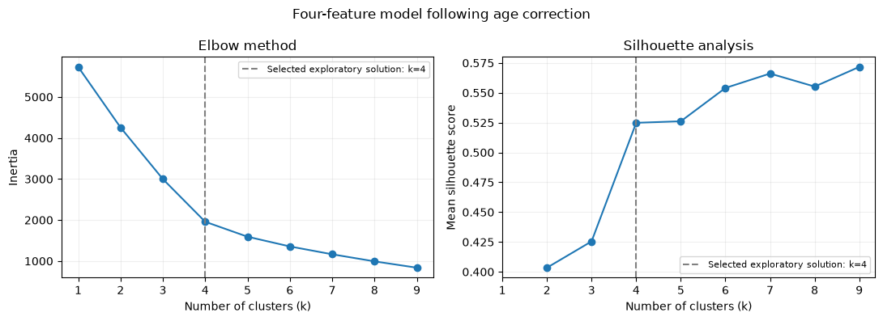

Figure 1: Elbow and silhouette analysis for the age-corrected four-feature dataset. The dashed line marks the selected exploratory solution, k = 4.
Inertia decreased substantially up to approximately k = 4, with smaller reductions thereafter. The silhouette score increased from 0.4255 at k = 3 to 0.5248 at k = 4. Higher values of k produced further improvements, with the highest tested score of 0.5717 occurring at k = 9.
Four clusters were retained as a balance between separation and interpretability, rather than as the silhouette-maximising solution. Inspection of the higher-k profiles showed that additional clusters largely subdivided similar employment and treatment-seeking groups by age. The four-cluster solution provided a simpler summary, although its relevance to the HR objective required further examination.

4.4 Final Clustering and Cluster Profiles
The final exploratory solution used K-Means with k = 4, n_init=10 and random_state=42 on the standardised four-feature dataset following age correction. All 1,433 respondents were retained.

Cluster | Number of respondents | Proportion of sample
Cluster 0 | 598 | 41.7%
Cluster 1 | 417 | 29.1%
Cluster 2 | 169 | 11.8%
Cluster 3 | 249 | 17.4%

Table 4: Cluster sizes for the final four-feature solution.

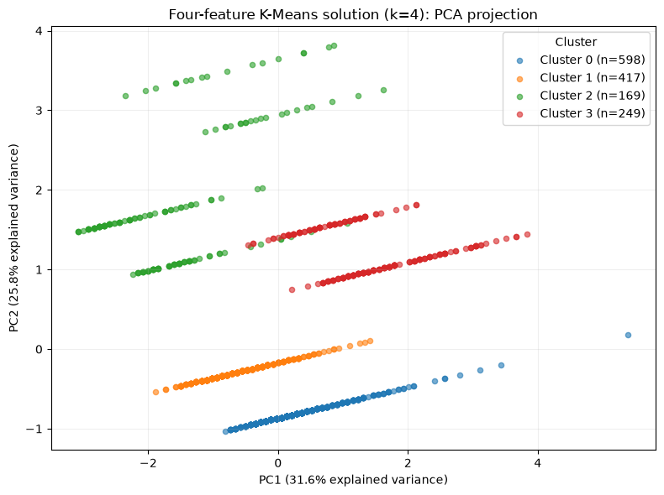
Figure 2: PCA projection of the age-corrected four-feature K-Means solution (k = 4). Colours indicate cluster membership. The two components explain 57.32% of the total variance.
Figure 2 displays the cluster assignments in two dimensions. The line-like patterns reflect the combination of three binary features and age: respondents sharing binary responses differ along the numerical age dimension. As the projection retains only part of the variance, the cluster profiles provide additional information for interpretation.

Feature | Cluster 0 | Cluster 1 | Cluster 2 | Cluster 3
Self-employed (%) | 0.0 | 0.0 | 22.5 | 100.0
Has previous employers (%) | 100.0 | 100.0 | 0.0 | 100.0
Has sought professional treatment (%) | 100.0 | 0.0 | 47.3 | 64.7
Mean age (years) | 34.2 | 33.4 | 30.8 | 37.3

Table 5: Final cluster profiles on their original scales. Binary percentages represent observed responses; mean age includes the two median-imputed corrections.
Clusters 0 and 1 contain non-self-employed respondents with previous employers and differ entirely in treatment-seeking history. Cluster 2 comprises respondents without previous employers, while Cluster 3 consists of self-employed respondents with previous employers. These profiles describe differences in the selected inputs; they do not independently establish differences in mental-health severity or support needs. Section 5 evaluates their relevance to the HR objective

5. Results and Critical Interpretation

The final four-cluster solution achieved a silhouette score of 0.5248 and produced interpretable groups based on employment circumstances, treatment-seeking, and age. However, separation within the selected feature space does not establish that the groups represent distinct mental-health support needs.
Clusters 0 and 1 share the same employment characteristics but differ entirely in treatment-seeking history. Because treatment-seeking was an input to clustering, this separation is partly a consequence of how the analysis was constructed. It should not be interpreted as independent evidence of different mental-health conditions. In particular, not having sought treatment does not establish an absence of need, and having sought treatment does not establish current severity.
Clusters 2 and 3 primarily reflect employment history and self-employment. These distinctions may provide context for further investigation, but the analysis does not demonstrate that either group requires a particular intervention. Age differences similarly describe the groups without establishing their causes or practical significance.
The preprocessing comparisons also revealed sensitivity to analytical choices. Correcting two implausible ages reduced the six-feature model’s silhouette score at k = 9 from 0.6206 to 0.5388. Excluding questions with apparent routing-related missingness avoided assigning potentially misleading answers, but narrowed the information available for clustering. The final feature set contains only one direct measure of mental-health help-seeking.
The results therefore provide an exploratory description of respondents rather than a validated basis for allocating HR support. Further analysis should examine more direct measures of mental-health experience and workplace support before translating these groups into recommendations for a particular organisation.

6. Recommended Next Steps
Further analysis should focus on whether the clusters reflect meaningful differences in mental-health experiences and support needs.
- Broaden the feature set. Consider variables addressing mental-health experiences, workplace support and barriers to seeking help, after assessing their missingness and applicability.
- Verify survey routing. Check the questionnaire to distinguish non-applicable questions from unanswered ones and choose suitable treatments for each.
- Assess cluster stability. Repeat clustering across random seeds and resampled datasets to examine whether similar groups consistently emerge.
- Evaluate information not used in clustering. Compare the groups on relevant survey responses excluded from the model. This would provide additional evidence beyond separation on the input features.
- Validate organisational relevance. Assess whether findings from this external survey apply to the organisation’s workforce before using them to guide support programmes.
These steps would help determine whether the current exploratory grouping can support the HR objective or whether a different feature set and analytical approach are needed.

7. Conclusion
This case study explored whether clustering respondents from the OSMI Mental Health in Tech Survey 2016 could inform an HR mental-health support programme. Three preprocessing iterations addressed the expansion caused by one-hot encoding, missing responses linked to employment circumstances, and implausible ages.
The final four-feature K-Means solution retained all 1,433 respondents and produced four interpretable clusters with a silhouette score of 0.5248. Four clusters were selected for interpretability, although nine clusters achieved the highest score within the tested range. Ward hierarchical clustering produced a comparable score at k = 4.
The resulting groups primarily reflected employment circumstances and treatment-seeking history. They therefore provide an exploratory description of respondents, rather than evidence of distinct support needs. Broader mental-health measures, stability checks and validation within the organisation are needed before these findings can guide HR interventions.

Bibliography

Han, J., Kamber, M., & Pei, J. (2011). Data mining: Concepts and techniques (3rd ed.). Morgan Kaufmann.
Jolliffe, I. T. (2002). Principal component analysis (2nd ed.). Springer. https://doi.org/10.1007/b98835
Open Sourcing Mental Illness. (2016). Mental health in tech survey 2016 [Data set]. Kaggle. Dataset page
Rousseeuw, P. J. (1987). Silhouettes: A graphical aid to the interpretation and validation of cluster analysis. Journal of Computational and Applied Mathematics, 20, 53–65. https://doi.org/10.1016/0377-0427(87)90125-7
Scikit-learn developers. (n.d.). Clustering. Scikit-learn documentation. Clustering documentation

Appendices

Appendix A: Full Cluster Profile Table
See Table 4 (Section 4.4) for the complete cluster profile across all six features used in the refined clustering analysis.

Appendix B: Supplementary Figures
See Figure 1 (Section 4.2) and Figure 2 (Section 4.2) for the elbow method curve and PCA cluster visualisation produced from the initial feature set.

